**ESP8266 AP mode usage**

**Written by Bill Lu**

WiFi manager under current folder is the latest version.

To user WiFi manager, simply put WiFiManager.cpp and WiFiManager.h under **C:\Users\your user name\Documents\Arduino\libraries\WiFiManager**

To run the code, you will first have to run initialize_EEPROM.ino to initialize the EEPROM.

Then, run mqtt_LED_wifi_encryption.ino.

Remember to change the board version to 2.00 or you will have compile errors.

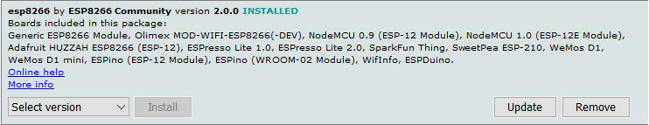

If your Arduino compiles successfully, you will see a hot spot in your WIFI.

The hotspot name is IOT and password is 22team22.

After connecting to IOT, type 192.168.4.1 to go to the main page.

In main page, you will see the following options.

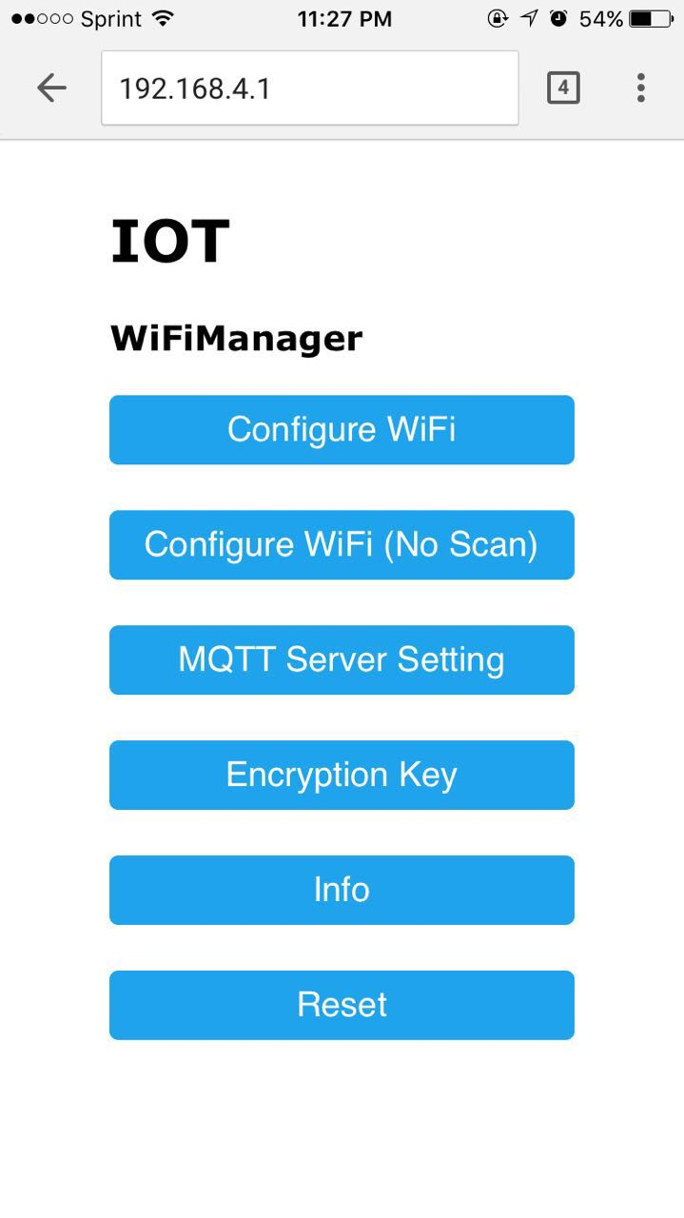

You will have to setup “Encryption Key”, “MQTT Server Setting” and “Configure WiFi” before making the program works.

Note: You must set “Encryption Key” and “MQTT Server Setting” before “Configure WiFi” because once you setup the WiFi, you will be directed to the following page and you will not be able to go back and set anything again.

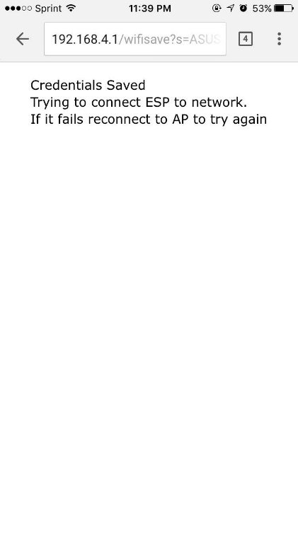

If all information are correct, the IOT hotspot will disappear and now you can use app to communicate to program through cloud MQTT.

If any information doesn’t match, the program will enter AP mode again and hotspot named IOT will appear in your wireless hotspot list again.